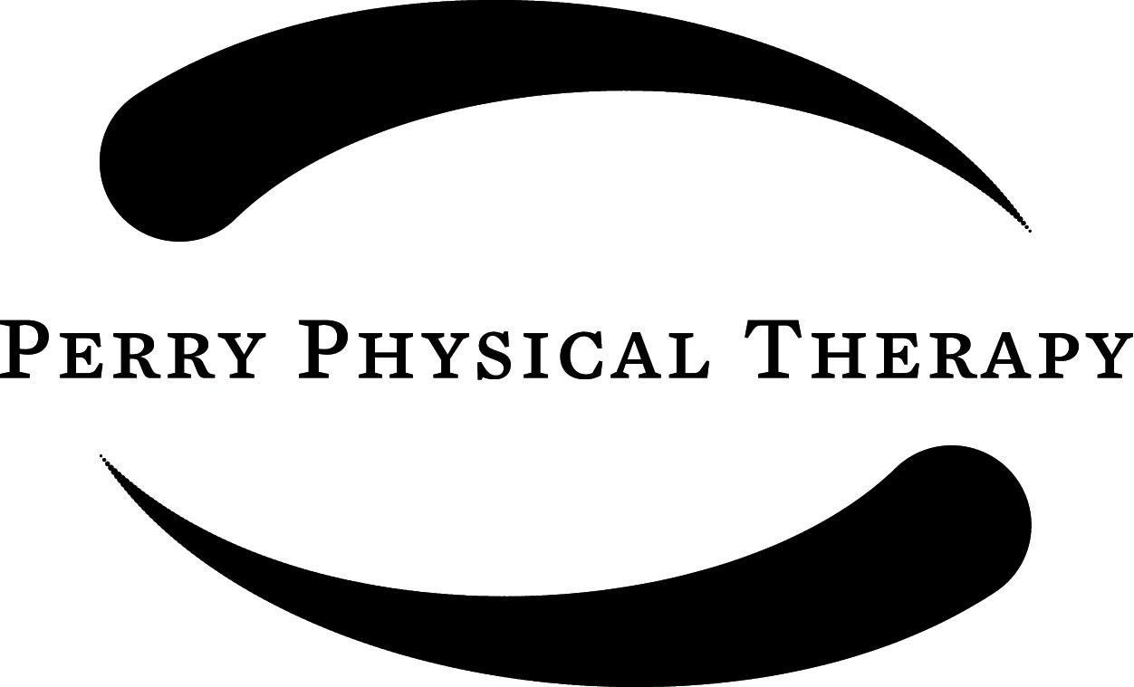

Strain & Counter Strain Treatment

Perry Physical Therapy is proud to offer the unique services of Strain & Counter Strain (SCS) to patients. This option is designed for patients who have finished their physician prescribed rehabilitation program, exhausted their insurance benefits or wish to bypass using their insurance altogether and just have the SCS treatment and not traditional physical therapy.

This option is not physical therapy and cannot be billed to insurances!
This is a cash program to be paid for prior to each visit. By signing below, the client agrees to assume the risk associated with manual stretching and hands on treatment, including but not limited to: pain, muscle soreness, fatigue, injury or lack of goal attainment. Patients currently being seen for physical therapy may not have this cash service concurrently. Prior to engaging in this treatment it is strongly recommended that patients who have not been seen by a physician for their current pain or problem do so. If it is felt that the client is not appropriate for SCS for any reason, or has other more pressing health related issues, he or she may be denied treatment and or referred to their doctor.

Available hours for SCS treatments are variable and dependent on the practitioner’s schedule. Weekend hours are available upon request.

Client Responsibilities:
- Please don’t come if you are ill, contagious or running a fever, so as not to infect the staff and current patients.
- Notify the staff if you are feeling ill, have questions or are uncomfortable about anything in the clinic.
- Please take responsibility for communicating with the front office regarding payment.
- Please use our staff as a resource, but realize that their first responsibility is to current patients. All questions and concerns will be addressed, but may not be able to be addressed at the time asked, due to the volume of patients in the clinic.

The fee for the PPT SCS program: $190 per 1 hour treatment, $150 per visit for 45 minute treatment, and $100 for 30 minute treatment.

By signing below, the client agrees to abide by the above guidelines and rules of the SCS program, and waive Perry Physical Therapy of any and all liability related to the administration of this unique hands-on treatment. The client also agrees to accept full responsibility for the financial, behavioral and health aspects, which have been stated.

Client – Please Print Please Sign Date

